- Label the following diagram.

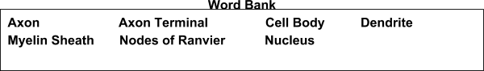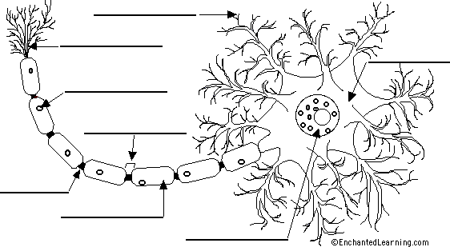

____ 2. Neurons that comprise the brain are

A. | SENSORY | B. | NEURONS | C. | MOTOR | D. | INTERNURONS

____ 3. Nerves carry impulses toward the brain are

A. | SENSORY | B. | NEURONS | C. | MOTOR | D. | INTERNURONS

____ 4. A simple spinal reflex goes along which of the following reflex arcs?

A. | MOTOR NEURON, ASSOCIATION NEURON, SENSORY NEURON
B. | SENSORY NEURON, MOTOR NEURON, ASSOCIATION NEURON
C. | SENSORY NEURON, ASSOCIATION NEURON, MOTOR NEURON
D. | MOTOR NEURON, SENSORY NEURON, ASSOCIATION NEURON

Place the stages of an action potential in order below. 1 should be the first and 5 should be the final stage/ending.

___5. A stimulus is received stage/beginning

___6. Sodium and Potassium channels open causing the cell to depolarize

___7. Na and K ions are located inside/outside of the cell in quantities that create a resting potential

___8. The Sodium/Potassium pump actively pumps Sodium and Potassium ions against the gradient of the cell causing repolarization

___9. Sodium and Potassium channels close

10.

Alright let’s take a little mental field trip. Imagine that you are at the beach; you can feel

the sand in between your toes and smell the salt water in the air. You decide to take a

little dip in the ocean. While in the water, you spot a shark. Explain what is going to

happen in your body and the nervous system from the moment you see this shark.

Include the following terms. (motor neuron, sensory neuron, association neuron, eye,

shark, legs and arms, the brain, Central nervous system, peripheral nervous system)

(20 pts)

Activity 2.2.2: The Secret to Signals

11. In the space below draw a cell membrane; label the following terms on your drawing (10pts)

Phosolipid Na+ Channel/K+ Channel

Na+ K+ Pump Na+ions & K+ Ions

Interior of cell Exterior of cell

12. When the neuron is at rest - which side of the membrane is positively charged? The exterior of the cell or the interior of the cell? (1pt)

13. What causes the inside of the membrane to reverse charge and begin the action potential? (1pt)

a. when K+ channels close and Na+ rushes in

b. when Na+ channels close the K+ rushes in

c. when the Na+ K+ pump stops working

d. none of the above

14. Does the Na+ K+ pump work via active or passive transport? Explain. (3pts)

15. Create a graph of the action potential generated in a neuron. Match the following parts to the correct location indicated on the graph. Write next to the word the letter of the chart. (4pts)

Depolarization Repolarization

Resting Potential Return to Resting Potential

16. Match the following descriptions utilizing the words in #15. (3pts)

a. This is when the potassium channel closes, sodium rushes inside the cell

b. This is when the sodium channel closes, potassium rushes outside the cell

c. This is when the Na+K+ is actively working

17. In the following picture label the following terms (6pts)

Axon Dendrite Vesicles

Neurotransmitter Synapse Receptor

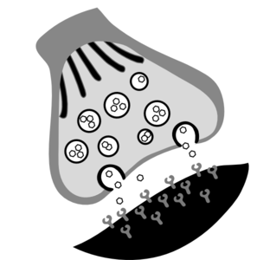

18. Describe how an impulse is sent from one neuron to another neuron. Be sure to utilize all the terms learned and used in Unit 2 and perhaps action potential! The more info you write the better! (15pts)

____ 19. Brain disorder in which a person loses neurons that release acetylcholine, causing difficulty remembering newly learned information, and mood and behavior changes.

a. | ALS - Lou Gehrig’s disease | c. | Parkinson’s disease
b. | Alzheimer’s disease | d. | Epilepsy

____ 20. Brain disease/disorder that progressively destroys the myelin sheaths of the neurons of the central nervous system is called disrupting the flow of information between the brain and body.

a. | Parkinson’s disease | c. | Multiple sclerosis
b. | Lou Gehrig’s disease | d. | Huntington’s disease

BONUS QUESTION
5PTS

DESCRIBE ONE NERVOUS SYSTEM DISORDER INCLUDING THE CAUSE, HOW IT IS DIAGNOSED, SIGNS & SYMPTOMS, TREATMENT, PROGNOSIS. INCLUDE 2 BIOMEDICAL PROFESSIONALS WHO COULD HELP IN THEIR TREATMENT EXPLAINING HOW THEY WOULD HELP.

